`
Report for: | Planning Policy Advisory Panel
Date of Meeting: | 6 March 2023
Subject: | Proposed Local Areas of Special Character – principles and draft criteria
Key Decision: | Yes
Responsible Officer: | Viv Evans, Chief Planning Officer
Portfolio Holder: | Councillor Marilyn Ashton, Deputy Leader of the Council, Planning & Regeneration Portfolio Holder
Exempt: | No
Decision subject to Call-in: | Yes
Wards affected: | All
Enclosures: | None (see background papers)

Section 1 – Summary and Recommendations
This report proposes to introduce a new local heritage designation namely:
‘Local Areas of Special Character’. This will be a non-statutory local designation relating to the historic and architectural interest and significance of an area and will supplement the national statutory designation of Conservation Areas. Such a designation will assist in the assessment of the design quality of development proposals rather than changing whether the development is acceptable in principle or impacting upon permitted development rights.

Recommendations:

The Planning Policy Advisory Panel is requested to:

- Note and comment on the proposal to introduce a new local heritage designation namely proposed ‘Local Areas of Special Character’ and the proposed criteria (paragraph 4.10); and
- Endorse consultation with local conservation groups / stakeholders with regards to the proposed criteria (including any amendments arising from the Panel’s discussion) prior to the matter being reported back to the Panel for consideration and referral to Cabinet for approval.

Reason:
Harrow benefits from an exceptionally diverse historic environment. It includes conservation areas designated under the Planning (Listed Buildings and Conservation Areas) Act 1990 as ‘areas of special architectural or historic interest, the character or appearance of which it is desirable to preserve or enhance’. There are many local areas in Harrow that might not meet the strict criteria for conservation area status but do have local heritage interest and significance. Accordingly, this report proposes a local designation for such Local Areas of Special Character. This proposed local designation is a parallel to the existing local designations of locally listed buildings and locally listed parks and gardens in Harrow for those buildings and areas that do not meet the strict criteria for national heritage designation. In accordance with national best practice a local consultation process is recommended.

Section 2 – Report

1.0 Introduction

1.1 The report incorporates the corporate priority concerning:
- Putting Residents First

It also reflects the overarching objective of Restoring Pride in Harrow.

1.2 Should the proposed designation of Local Areas of Special Character be confirmed with the criteria outlined below (subject to consultation), the improved protection will help maintain the historical local character of areas or neighbourhoods within Harrow which residents cherish and value.

2.0 Options considered

2.1 The options of not introducing this new designation, nor subjecting the proposed criteria for designation to local consultation, were considered but this would be contrary to the obligations placed on the Council under the NPPF which states in paragraph 192 that ‘Local planning authorities should maintain or have access to a historic environment record. This should contain up-to-date evidence about the historic environment in their area and be used to: a) assess the significance of heritage assets and the contribution they make to their environment’. It would also be at odds with the approach Harrow takes to buildings and landscapes of local interest but not worthy of national interest via national versus local listing.

2.2 Consultation is considered good practice as it enables the criteria to be considered by others and potential improvements offered, as well as allowing stakeholders to comment on the principle of establishing a process for designating LASCs.

2.3 Section 4 below considers the matters (options) that need to be considered in formulating the criteria as well as approaches adopted elsewhere. The preferred criteria are outlined in paragraph 4.10 below.

3.0 Background

What is a conservation area?

3.1 As noted in the report to the Panel on 3 October 2022, Conservation Areas are designated under the Planning (Listed Buildings and Conservation Areas) Act 1990 which states in section 69 that 'every local planning authority shall from time to time determine which parts of their area are areas of special architectural or historic interest the character or appearance of which it is desirable to preserve or enhance, and shall designate those areas as conservation areas'.

3.2 Harrow has adopted four Supplementary Planning Documents (SPDs) that cover the borough’s existing conservation areas. Those documents include local guidance as to what is considered to represent ‘special architectural or historic interest’ in the Harrow context. In order for an area to be appropriate for designation as a conservation area, it must fulfil two of the following criteria (as outlined in the SPDs):

(a) Areas with a high concentration of Listed Buildings, whether statutorily or locally listed;
(b) Areas of historical, social, economic and/or architectural merit;
(c) Areas with a high proportion of buildings built prior to 1920, which remain largely unaltered;
(d) Areas built post 1920 that are innovative in planning or architectural detail, and where a large proportion remain unaltered;
(e) A significant group of buildings with distinct physical identity and cohesiveness;
(f) Areas which have a special quality, where the site layout and landscaping are of exceptionally high quality and/or contain historic open space, natural landmarks, topographical features or features of local distinctiveness

When not to designate?

3.3 The National Planning Policy Framework (NPPF) (2021) states in paragraph 191 that:

‘When considering the designation of conservation areas, local planning authorities should ensure that an area justifies such status because of its special architectural or historic interest, and that the concept of conservation is not devalued through the designation of areas that lack special interest’.

3.4 Historic England are the Government’s advisers on matters of heritage. They have published guidance entitled: ‘Conservation Area Appraisal, Designation and Management Historic England Advice Note 1’ [HEAN 1] (Second Edition) – February 2019. They highlight the above requirement of the NPPF twice in their guidance since it was also contained in earlier iterations of the NPPF.

3.5 In addition, HEAN1 mirrors the requirements of s.69 of the Act that there shall be both ‘special interest’ and ‘desirability to preserve or enhance’ for CA designation as it states in paragraph 11 that there is: ‘likely to be a stage when a decision would need to be taken as to the significance of an area and the likelihood of conservation area designation addressing relevant problems within the area. This is unlikely to be a lengthy process, the purpose being to consider whether an area has:
a) sufficient architectural or historic interest for the area to be considered ‘special’?
b) whether this is experienced through its character or appearance? and
c) whether it is desirable for that character or appearance to be preserved or enhanced, and what problems designation could help to solve’.

3.6 Thus, it indicates that where an area meets the criteria for designation, on occasion designation may not be desirable and prompts consideration as to what problems designation could help solve in order to determine the desirability of designation.

3.7 It is noted that there have been instances in the past (including recently) where areas that residents have sought to be designated as a Conservation Area have been assessed and determined not to have the special architectural and historic interest required to be designated as a statutory Conservation Area. These areas however do have a degree of historic interest that may warrant identification locally but at present there is no such local mechanism to do this.

4.0 Proposed Local Area of Special Character designation

What is a Proposed Local Area of Special Character?

4.1 The proposed local area designation should be seen in contrast to the Conservation Area designation which are a heritage designation governed by national legislation and the principle of what makes such an area ‘special’ needs to be considered in the national context; it is therefore a high threshold. Conservation area designation also reduces permitted development rights (i.e. what can be done without planning permission).

4.2 At a local level, unlike many Local Planning Authorities, Harrow currently does not have a local form of area designation based on the architectural and / or historic interest / significance of an area (a similar concept to Harrow’s ‘Local List’ of buildings compared to statutory listed buildings, which are designated at a national level). There are areas within Harrow that, whilst they do not meet the grade for Conservation Area status, do have a level of interest / significance that would benefit from formal local recognition, in order to help in the assessment of planning applications.

4.3 This report therefore considers the merits of establishing a ‘Local Area of Special Character’ designation as a mechanism to formally recognise certain areas as local heritage assets. Historic England’s national guidance in their document ‘Local Heritage Listing Historic England Advice Note 7’ highlights the reasons for Local Planning Authorities to hold an up to date and complete heritage list recognising local heritage assets:

  - ‘Local heritage listing is a means for a community and a local planning authority to identify heritage assets that are valued as distinctive elements of the local historic environment.
  - It provides clarity on the location of assets and what it is about them that is significant, helping to ensure that strategic local planning properly takes account of the desirability of their conservation.
  - Sometimes it may also help identify overlooked assets of high significance, which may warrant consideration for designation at the national level, too.
  - The process of preparing a local heritage list not only allows communities to identify local heritage that they would like recognised and protected, but it is also an opportunity for local authorities and communities to work in partnership.
  - Creating a local heritage list also helps to improve access to clear, comprehensive and current information about the historic environment at the local level through resources such as Historic Environment Records (HERs) which can speed up the planning process’.

What would designation mean in practice?

4.4 It should be noted that this local designation (unlike Conservation Areas) would not change permitted development rights. There would be no additional requirements for planning permission on residents, nor any additional requirements for permission to undertake works to trees within the area (that aren’t covered by a Tree Preservation Order).

4.5 However, the designation would be a material consideration for any planning applications that are received within, or in the setting of that area. It would mean when planning applications are being determined they would need to be assessed in terms of whether what is being proposed preserves what is special about the heritage interest of that area, either via a direct impact on it or via impact on its setting. It would mean relevant heritage policies relating to non-designated heritage assets in the NPPF and Harrow Local Plan would apply i.e. the Core Strategy policy CS1 and Development Management policy DM7. NPPF paragraph 203 would apply which states:

‘The effect of an application on the significance of a non-designated heritage asset should be taken into account in determining the application. In weighing applications that directly or indirectly affect non-designated heritage assets, a balanced judgement will be required having regard to the scale of any harm or loss and the significance of the heritage asset’.

4.6 Additionally, the proposed Local Area of Special Character designation is primarily a design tool that seeks to formally identify areas that ‘are valued as distinctive elements of the local historic environment’ [see paragraph 4.3(a) above] so that the identified characteristics can be considered when assessing development proposals within the area. Identification of such areas add a further design consideration when assessing planning applications rather than directly influencing the principle of development within the area.

What would the criteria for designation be?

4.6 The proposed criteria for designation must connect back to national heritage policy and guidance on the significance of heritage assets. Harrow’s criteria for conservation area status are outlined above and similarly do so, but also relate back to national heritage legislation, namely the Planning (Listed Buildings and Conservation Areas) Act 1990’s definition of conservation areas as ‘areas of special character and appearance’ that it is ‘desirable to preserve or enhance’. Wider national and local policy and guidance relating to heritage significance includes the NPPF which defines a heritage asset as:

‘A building, monument, site, place, area or landscape identified as having a degree of significance meriting consideration in planning decisions, because of its heritage interest’. (Annex 2: Glossary)

It defines significance (for heritage policy) as:

‘The value of a heritage asset to this and future generations because of its heritage interest. The interest may be archaeological, architectural, artistic or historic. Significance derives not only from a heritage asset’s physical presence, but also from its setting.’ (Annex 2: Glossary)

4.7 The Historic England guidance document entitled Local Heritage Listing Historic England Advice Note 7 provides a list of various criteria likely to indicate the nature of heritage significance/interest including: age, rarity, aesthetic interest, group value, historic association, and social and communal value.

4.8 A review of other boroughs’ approaches to identifying local areas of special character (the names of the areas vary amongst boroughs) has indicated a number of relevant considerations that have been informed the development of the proposed Harrow criteria. These considerations include:

- The area must be of heritage significance, consistent with the NPPF (i.e. such areas are considered ‘undesignated heritage assets’ in the NPPF, so must have a ‘degree of significance’ (see paragraph 4.6 above).
- Criteria generally relate to three elements of the built and natural environment, namely architectural, townscape and landscape.
- Key considerations generally relate to the quality of an area and level of preservation (with respect to architecture, townscape and landscape).
- There is no common approach to drafting criteria. Some are lists of general points / considerations, others are more descriptive regarding the level of quality and preservation required, others take a ‘scored’ approach linked with the assessment of conservation areas (i.e. scores above a certain number are designated a conservation area, scores between a certain range are identified as local areas of special character and scores below a certain level are not identified as either.

4.9 The suggested Harrow criteria for designation for Local Area of Special Character relates back firmly to this national and local guidance on the criteria for local heritage assets, as well as the drafting considerations identified above. Regard has also been given to the local criteria for conservation area status, albeit recognising the lower local bar for designation of local heritage assets.

4.10 The proposed criteria are as follows:

- The area must be of heritage significance.

- One or more of the following criteria need to be met:
a. Townscape of locally cohesive, well-preserved quality.
b. Architecture of locally cohesive, well-preserved quality.
c. Landscape of locally distinctive and well-preserved quality.

Overall, an area must have discernibly higher quality and degree of intactness than other parts of the borough (other than designated conservation areas, that have special architectural or historic interest), thereby demonstrating distinctiveness.

4.11 The above criteria includes a requirement that an area has heritage significance, consistent with the NPPF. The three sub-criteria under criterion 2 reflect the typical areas of consideration for LASCs. The final element / narrative essentially seeks to reflect the primary purpose of LASCs so that when an area is being considered, regard is given to this.

4.12 A key element of the proposed criteria is the ‘relativity’ of an area compared to the rest of the borough, including designated conservation areas. This is because the primary rationale for establishing Local Areas of Special Character is that there are areas in the borough that have a level of quality and preservation that distinguishes them compared to other areas of the borough but are not of sufficient quality and preservation that means they meet the threshold of special architectural or historic interest required to be designated a conservation area.

4.13 In terms of the broad character of the borough in relative terms, the Harrow Characterisation Study (August 2021) provides some useful background that would be used to assist in this process (relevant extracts are included in Appendix 1). From these extracts, the rapid development of the borough between the 1920s and 1940s is evident, this is reflected in the significant proportion of the borough identified as having a suburban building typology. As with conservation areas, the identification of LASCs would need to be sufficiently robust and selective so as not undermine the principle that they represent areas of a level of quality and preservation that distinguishes themselves from the rest of the borough but do not have the level of special architectural or historic interest that would warrant designation as a conservation area.

5.0 Process and timeframes

5.1 There are no statutory requirements to consult on the criteria for LASC, however as best practice and Historic England recommendations, it is proposed that Harrow will consult with local conservation groups including the Conservation Area Advisory Committee on the criteria proposed. The results of the consultation and any associated amendments to the draft criteria will be presented to the Panel for consideration before being reported to Cabinet for formal adoption.

5.2 Once any LASC criteria are adopted, in the first instance it is proposed that the two areas recently assessed for Conservation Area status (Butler Avenue and surrounding roads, West Harrow and Suffolk Road, North Harrow) and found not to be of sufficient interest to be designated as a Conservation Area will be assessed to determine if they meet these criteria and warrant proceeding to consultation on being designated as a LASC. Additionally, subject to resourcing and other priorities, the list of potential areas for consideration for Conservation Area assessment (maintained by the Council’s Conservation Officer as part of ongoing work) will be assessed for their suitability for Conservation Area status and if not found to warrant designation as such, assessed against the new LASC criteria at the same time.

5.3 Additionally, any future consideration of potential areas for identification as LASCs would be in part informed by the Harrow Characterisation Study (August 2021) with respect to areas of potential historic interest and which are potentially distinctively different to the borough more generally.

5.4 The Government is currently consulting on potential changes to the National Planning Policy Framework with potential further changes / entirely new document likely to be consulted on in the future. Additionally, the Government is also proposing National Development Management Policies (NDMP) that would effectively be used to determine planning applications and influence what policies can be included in the new Harrow Local Plan and the weight that can be given to the current Local Plan. The coverage of the NDMPs is yet to be determined, but if policy/ies relating to heritage were proposed, it maybe necessary to review any LASC criteria (as well as the local criteria used for conservation areas). It would also be good practice to review the criteria after a few years of implementation.

Ward Councillors’ comments – not sought as covers all wards.

Risk Management Implications

Risk included on Directorate risk register? No

Separate risk register in place? No

There are no significant risks arising from the recommendations – information report only.

Legal Implications

The Council has a statutory duty and is required under section 69(2) of the Planning (Listed Buildings and Conservation Areas) Act 1990 to carry out reviews ‘from time to time’ to determine whether any parts or further parts of their area should be designated as conservation areas; and if it so determines, that part(s) shall be so designated. It follows that those not worthy, but still of heritage value, are recognised in accordance with the NPPF paragraph 192’s requirement that: ‘Local planning authorities should maintain or have access to a historic environment record. This should contain up-to-date evidence about the historic environment in their area and be used to: a) assess the significance of heritage assets and the contribution they make to their environment’. The introduction of Local Areas of Special Character would assist the Council in meeting this criteria as they will identify areas of local significance and assist in this been taken into account when considering development proposals.

Financial Implications

The costs of establishing the system of Local Areas of Special Character will be met from within the existing revenue budgets of the Council’s Planning Policy team / built conservation function. The level of activity in identifying such areas will be influenced by the wider work programme and priorities of the conservation function, including ensuring the Council meets its statutory obligations with respect to designated heritage assets.

Equalities implications / Public Sector Equality Duty

Was an Equality Impact Assessment carried out? No

EqIA is not considered necessary in respect of the setting of criteria and future identification of Local Areas of Special Character. Such a proposal is based on the architectural / townscape / landscape and historic merit of an area. Furthermore, the higher order Local Plan policy that contains the criteria against which development within Local Areas of Special Character will be assessed was subject to an equalities impact assessment prior to its adoption.

Council Priorities

The decision sought will help the Council meet the priority of improving the environment and Pride in Harrow by helping ensure the attractiveness of the borough as a place to live and demonstrating that the Council seeks and listens to the views of its residents (by Putting Residents First).

Section 3 - Statutory Officer Clearance

Chief Officer: Viv Evans
Signed off by the Chief Planning Officer
Date: 27 February 2023

Mandatory Checks

Ward Councillors notified: No – affects all wards

EqIA carried out: NO - information report only
If ‘NO’ state why an EqIA is not required for Cabinet to take a decision

EqIA cleared by: N/A

Section 4 - Contact Details and Background Papers
Contact: David Hughes, Planning Policy Manager, david.hughes@harrow.gov.uk
Background Papers:
Harrow Conservation Areas and Supplementary Planning Documents (SPDs) - https://www.harrow.gov.uk/planning-developments/biodiversity-conservation

Report to Planning Policy Advisory Panel – 3 October 2022 - https://moderngov.harrow.gov.uk/documents/s178534/Proposed%20consideration%20of%20three%20areas%20for%20Conservation%20Area%20status.pdf

Appendix 1 – Extracts from the Harrow Characterisation Study (August 2021)

Existing and Historic Character

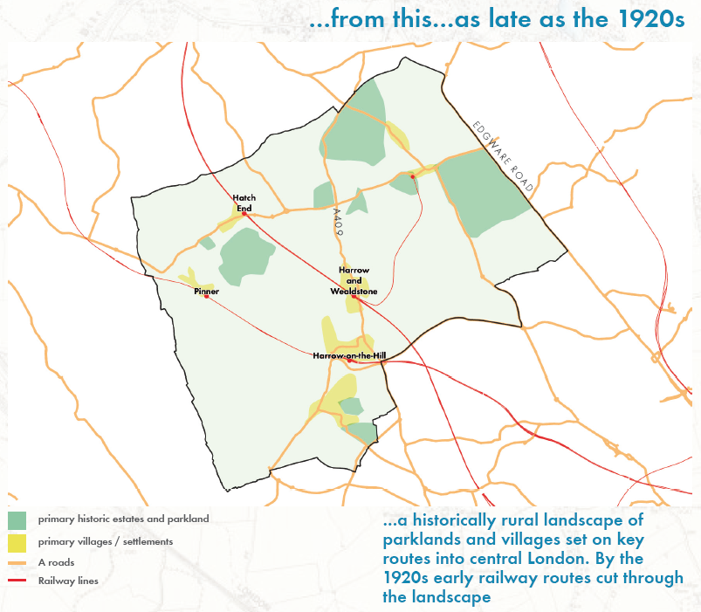

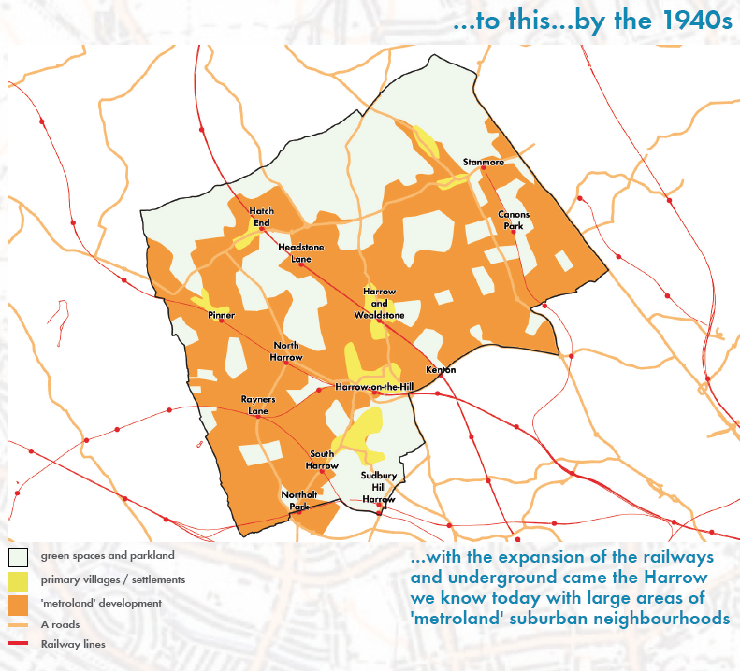

Designated Heritage Assets
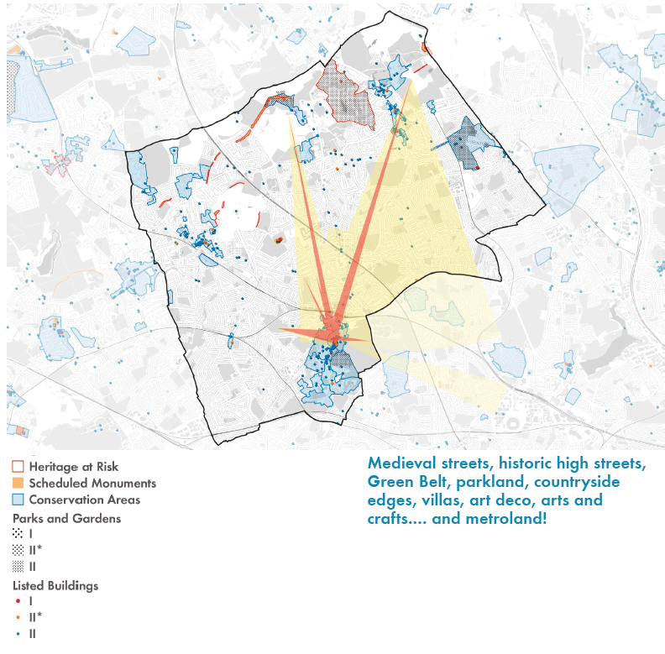

Building Typologies
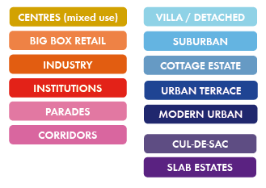
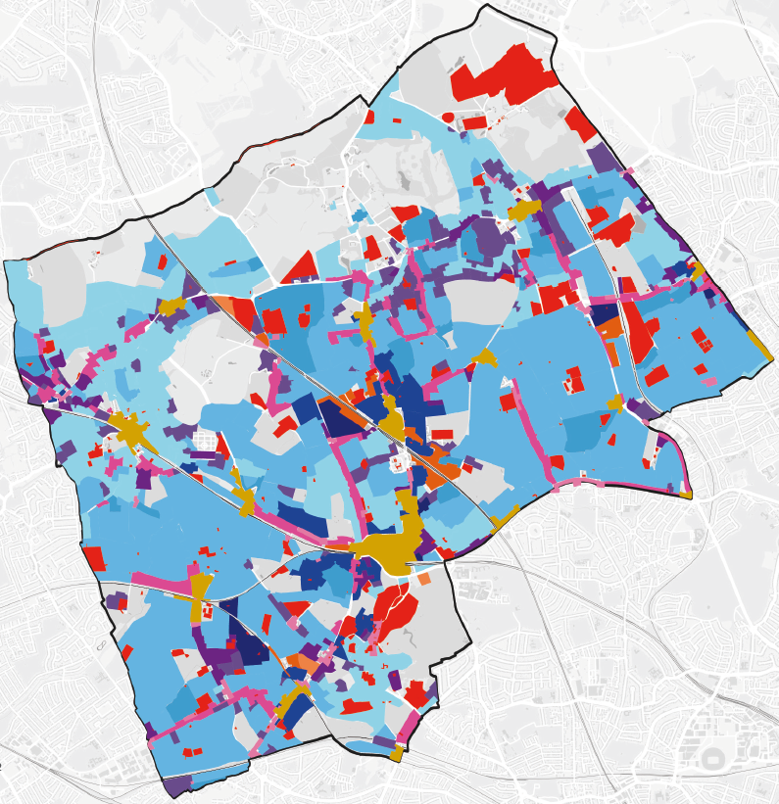

These criteria were originally agreed by the Development Control Committee on 31 August 1998 as the criteria to be adopted in Harrow.
The NPPF defines a ‘Designated heritage asset’ as: A World Heritage Site, Scheduled Monument, Listed Building, Protected Wreck Site, Registered Park and Garden, Registered Battlefield or Conservation Area designated under the relevant legislation. (Annex 2: Glossary)
Reflecting Local Heritage Listing Historic England Advice Note 7, particularly that local heritage assets should be ‘distinctive’ (see paragraph 4.3 above).
This process will also involve updating the assessment of Butler Avenue and surrounding roads with respect to feedback from West Harrow Community Forum, as per the Panel’s discussion and request from its meeting on 30 November 2023.

